SkillBridge



Submitted by

Name:
Shadab Ul Hassan
Roll No.:
F22BINFT1M01217

Submitted to

Supervisor Name:
Ms. Kainat

Department of Information Technology
Faculty of Computing
The Islamia University of Bahawalpur

Summery

SkillBridge

Career selection is one of the most important and challenging decisions in a student’s academic life. Many students face confusion due to limited awareness of career options, lack of proper guidance, and uncertainty about their own skills and interests. Traditional career counseling methods are often manual, time-consuming, and do not provide personalized recommendations. To address these challenges, SkillBridge is developed as an AI-powered career guidance platform that assists students in making informed career decisions.

SkillBridge analyzes students’ profiles by collecting information such as academic performance, skill sets, interests, and personality traits through structured questionnaires and assessment modules. The system processes this data using intelligent algorithms and machine learning techniques to Identify patterns and match students with suitable career domains. Based on this analysis, the platform generates personalized career recommendations that align with the student’s abilities and potential.

In addition to career recommendations, SkillBridge provides detailed career insights including job scope, required qualifications, essential skills, and current industry trends. This helps students understand not only which career suits them best, but also what steps they need to take to achieve their career goals. The system is designed with a user-friendly and interactive interface to ensure ease of use for students and administrators.

This Software Design Document describes the overall design and structure of the SkillBridge system. It includes details of the application architecture, data model schema, and user interface design. The purpose of this document is to serve as a technical blueprint for the development and implementation of the system, ensuring scalability, maintainability, and effective performance

Table of Content
- Summary
- Application architecture
      - System overview
      - Architectural pattern
      - System components
      - Controllers
      - Api & recommendation engine
      - External APIs and libraries
      - UML diagram
      - Coding conventions
- Data model schema
- Database overview
- Entity description
- User
- Assignment
- Carrer
- Recommendation
- Entity relationship
- Er diagram
- User interface
- Design philosophy
- Screen layout and navigation
- List of screens
- Home page
- Login & registration page
- User dashboard
- Assessment page
- Career recommendation
- Admin pane

Application Architecture of SkillBridge

1. Overview
SkillBridge is an AI-powered career guidance platform designed to help students discover suitable career paths based on their skills, interests, academic performance, and personality traits. The application architecture is designed to efficiently handle data collection, processing, and recommendation generation while providing an intuitive and responsive user interface.
The architecture follows a modular and layered approach to ensure scalability, maintainability, and security.

2. Architectural Layers

a) Presentation Layer (Frontend)
Purpose:
Handles all interactions with users, collects input, and displays results.
Components:
- Web Interface: Responsive web portal for students.
- Mobile Interface: Mobile-friendly or hybrid app interface for accessibility.
- UI Components: Questionnaires, dashboards, and recommendation views.
Technologies:
React.js / Angular for web, Flutter / React Native for mobile.

b) Application Layer (Backend / Business Logic)

Purpose:
Core logic for processing inputs, managing workflows, and generating recommendations.

Components:
User Management Module:
Handles registration, login, and profile management.
Assessment Module:
Processes questionnaire and academic data.
Career Recommendation Engine:
Uses AI/ML algorithms to match students with career paths.
Analytics Module:
Tracks user progress and provides insights.
Technologies:
Node.js / Django / Spring Boot, RESTful APIs, Python for ML processing.
c) Data Layer
Purpose:
Stores and retrieves structured and unstructured data required for system operations.
Components:
Student Data Repository:
Stores user profiles, academic records, and assessment results.
Career Database:
Contains information about careers, required skills, qualifications, and job trends.
Logs & Analytics Database:
Tracks user interactions and system performance.
Technologies:
PostgreSQL / MySQL for relational data, MongoDB for unstructured data, Elasticsearch for search.

d) AI & Machine Learning Layer
Purpose:
Implements intelligent algorithms to provide personalized career recommendations.
Components:
Data Preprocessing:
Cleans and normalizes user data for analysis.
Prediction Models:
Uses supervised learning, clustering, or recommendation algorithms.
Feedback Loop:
Learns from user choices and system performance to improve recommendations.
Technologies:
Python, C++ HTML.

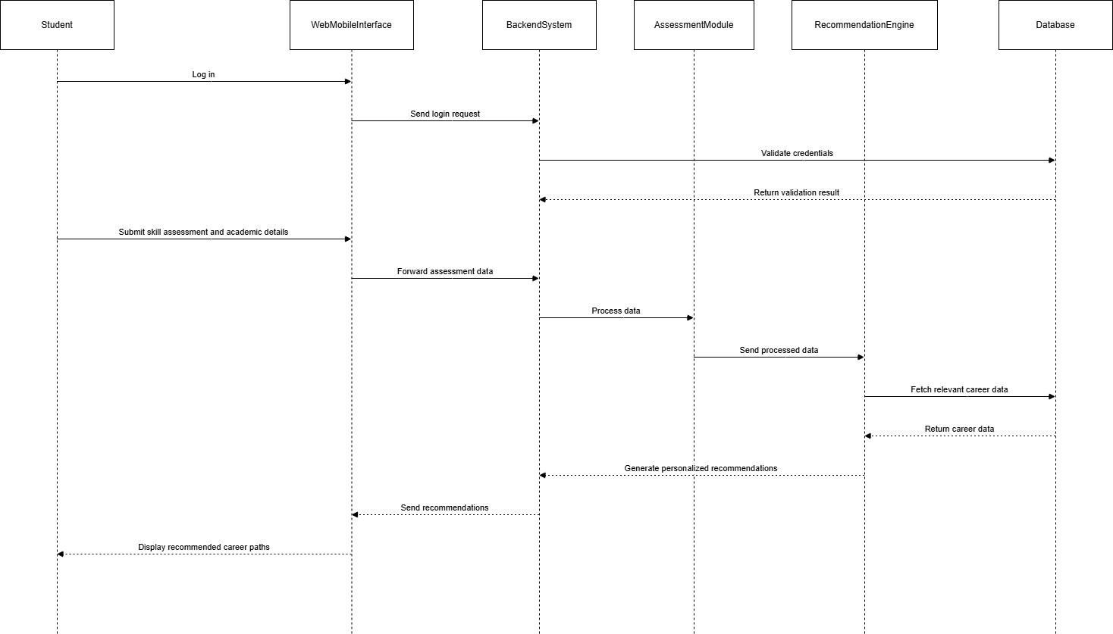

Data Model Schema – SkillBridge

1. Overview
The data model of SkillBridge defines how data is stored, organized, and related within the system. It supports user management, assessments, AI-based career recommendations, and feedback collection. The schema is designed to ensure data integrity, scalability, and efficient retrieval.

2. Entities and Attributes
2.1 user
Stores Basic Authentication And Role Information
ATTRIBUTE | DATA TYPE | DESCRIPTION
User ID | Integer | Unique user IDentifier
Name | String | Full name of user
E mail | String | User email
Password | String | Encrypted password
Role | String | Student admin
Created at | Date time | Account creation date

2.2 Student
stores student-specific information.
ATTRIBUTE | DATA TYPE | DESCRIPTION
Student ID | Integer | Unique student ID
User ID | Integer | Reference user
Skills | Text | Student skills
Interests | Text | Student interests
Academic record | Text | Academic performance
Personality type | String | Personality assessment result
2.3 ADMIN
stores admin specific details.
ATTRIBUTE | DATA TYPE | DESCRIPTION
Admin ID | Integer | Unique admin ID
User ID | Integer | References user

2.4 ASSESSMENT
stores skill and aptitude assessment data.
ATTRIBUTE | DATA TYPE | DESCRIPTION
Assessment ID | Integer | Unique assessment ID
Student ID | Integer | References student
Assessment type | String | Skill aptitude
Score | Float | Assessment score
Created at | Date time | Assessment date

2.5 CARRER
Stores Carrier Related Information
ATTRIBUTE | DATA TYPE | DESCRIPTION
Carrere ID | Integer | Unique career ID
Title | String | Career title
Description | Text | Career description
Required skills | Text | Required skills
Qualification | Text | Required qualification
Job trend | Text | Market demand

2.6 RECOMMENDATION
Stores Generated Career Recommendation
ATTRIBUTE | DATA TYPE | DESCRIPTION
Recommendation id | Integer | Unique recommendation id
Student id | Integer | References student
Career id | Integer | Reference career
Match score | Float | Ai confidence score
Generated at | Date time | Recommendation

2.7 FEEDBACK
Stores student feedback on recommendations.
ATTRIBUTE | DATA TYPE | DESCRIPTION
Feedback id | integer | Unique feedback id
Student id | Integer | Reference student
Career id | Integer | Reference career
Rating | Integer | Rating (1-5)
Comments | Text | Feedback comments

3 RELATIONSHIP (ER PERSPECTIVE)
RELATIONSHIP | TYPE
User → student | One-to-one
User → admin | One-to-one
Student → assessment | One-to-many
Student→ recommendation | One-to-many
Career → recommendation | One-to-many
Student→ feedback | One-to-many
Career → feedback | One-to-many

4. Data Model Characteristics
- Normalization: Eliminates redundancy
- Referential Integrity: Enforced via foreign keys
- Scalability: Supports large number of students and careers
- Security: Sensitive data stored securely
- AI Compatibility: Structured for ML analysis

Data Model Diagram
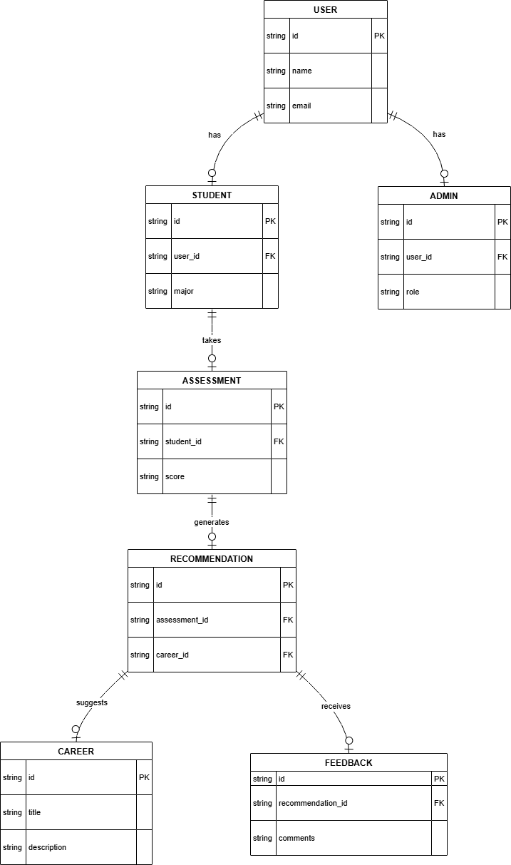

User Interface Design SkillBridge

1. Overview
The User Interface (UI) of SkillBridge – AI-Powered Career Guidance System is designed to be simple, intuitive, and user-friendly. The interface allows students to easily interact with the system, complete assessments, and view personalized career recommendations, while enabling administrators to manage system data efficiently.
The UI follows a responsive design approach, ensuring smooth usage on desktop, tablet, and mobile devices
2. Design Principles
The UI of SkillBridge is developed based on the following principles:
- Simplicity: Clean layout with minimal complexity
- Consistency: Uniform colors, fonts, and navigation across all screens
- Accessibility: Easy navigation for users with different technical backgrounds
- Responsiveness: Works across different screen sizes
- Usability: Clear buttons, labels, and instructions
3. User Roles and Interfaces

3.1 Student Interface
The student interface allows users to register, provide personal and academic information, complete assessments, and receive career recommendations.

a) Login & Registration Screen
- Email and password fields
- Register new account option
- Forgot password option
- Secure authentication
Purpose: Allows students to securely access the system.

b) Student Dashboard
- Overview of profile status
- Quick access to assessments
- Recommendation summary
- Navigation menu
Purpose: Acts as the main control panel for students.

c) Profile Management Screen
- Personal information
- Academic details
- Skills and interests
- Personality traits
Purpose: Collects accurate data for personalized recommendations.

d) Assessment Screen
- Skill assessment questions
- Aptitude/personality tests
- Progress indicator
- Submit button
Purpose: Gathers data required by the AI recommendation engine.

e) Career Recommendation Screen
- List of recommended careers
- Match score for each career
- Career details (skills, qualifications, job trends)
Purpose: Displays AI-generated career guidance.

f) Feedback Screen
- Rating system (1–5)
- Comment section
- Submit feedback button
Purpose: Collects student feedback to improve recommendations.

3.2 Admin Interface
The admin interface provides system management and monitoring functionalities.

a) Admin Dashboard
- Total users
- Total assessments
- Popular career paths
- System analytics
Purpose: Gives an overview of system performance.

b) User Management Screen
- View student list
- Activate/deactivate accounts
- Manage user roles
Purpose: Controls system users.

c) Career Management Screen
- Add, update, or delete career data
- Define required skills and qualifications
Purpose: Maintains accurate career information.

d) Reports & Analytics Screen
- Assessment statistics
- Recommendation accuracy
- User activity reports
Purpose: Supports decision-making and system improvement.

4. Navigation Structure
- Top navigation bar for quick access
- Sidebar menu for major modules
- Breadcrumbs for user orientation
- Logout option available on all screens

5. UI Technologies
- Frontend: HTML5, CSS3, JavaScript
- Frameworks: React.js / Angular
- Design Tools: Figma, Canva, Draw.io
- Backend Integration: Restful APIs

6. UI Security Features
- Secure login system
- Role-based access control
- Input validation
- Session management

7. Advantages of the UI Design
- Easy to learn and use
- Reduces user confusion
- Enhances user experience
- Supports AI-driven decision-making

“This SDD provides a detailed specification and design for the SkillBridge system and serves as a foundation for its successful implementation and evaluation

